**INTRODUCTION**

* 1. **INTRODUCTION:**

The purpose or objective of this system is to digitalize and create an automated system. The system will perform the task like adding the new member to the gym and other stuff required in managing the gym properly.

The present scenario in the gyms is that the records are kept by writing in a file on the paper. Every management task is done manually. This creates a system unreliable and confusing to keep the correct track of the records.

The maintenance of the system like this is hardly required until it needs to change any part of the system. The information about the various things contained in the system are like members, trainers, equipment can get by just a few clicks unlike the paper documents required the serious reading for such information.

It also helps the users in reducing the carbon footprint as the amount of paper used in company reduces.

This also helps in keeping the standard width of the management system as if there is a case where the administration involves more than one person to manage the gym.

This will improve the transparency between the members which is always a good quality in the system. It will also give the layer of security to the administration and the users that only authorized users can access by their credentials.

**1.2 OVERVIEW:**

**SOF** (Science of Fitness) is a gym management system that provides a system which handles the information of the people coming to the gym and maintaining their health care.

It takes care of all their health information. It even maintains the data of all the supplements used by the people who joins the gym.

Data will be stored in the database. It also maintains gym records.

* 1. **OBJECTIVE**

The purpose or objective of this system is to digitalize and create an automated system. The system will perform the task like adding the new member to the gym, removing the member or keeping the records.

The information about the various things contained in system are like members can get by just a few clicks unlike the paper documents required the serious reading for such information.

This will improve transparency between the members which is always a good quality in the system. It will also give the layer of security to the administration and users that only authorized users can access by their credentials.

* The main objective of the project is to design and develop a user friendly efficient computerized Gym Management System
* An accurate system without any data redundancy.

**LITERATURE SURVAY**

Gym Management System of Taurama Fitness centre by Computer University Of Indonesia. [1] Taurama Fitness centre is one of the few gym training center in port Moresby, Papua New Guinea which was founded in 2009, by johnson Waldford. However , as off its experience, there are some major setbacks or problems that are encountered at Taurama Fitness centre. The setbacks or problems encountered are mainly related to member registration procedures and storing data contents. It was time consuming and inefficient. The major problem faced by the authority is that they couldn't able to manage the customers data securely and they misinterpreted the data of the customers.

In order to overcome these setbacks, it is proposed that the gym management system be designed. A gym management system is an information system that manages data information daily and helps record information and transaction from members and non-members. This management system will cater for member registration procedures, data handling and maintenance and etc. This can help in solving this problems and become more reliable and efficient for the authority.

Our proposed system focuses on receiving the data from the customer and the visitor and handles it properly with security. No other person than the admin is authorized to get access into the system and make changes to the data.

**PLANNING**

The present scenario in the gyms is that the records are kept by writing in a file on the paper. Every management task is done manually. This creates a system unreliable and confusing to keep the correct track of records.

Our system will perform the task like adding the new member to the gym, removing the member or keeping the payments records and other stuff required in managing the gym properly. The planning of the system is done in a way such that it should be more reliable for the users and the admin.

We introduced the system to reduce the manual work effectively as there is the backend of the system which will take care of synchronizing and updating of the data for the system.

**HOME PAGE:** The basic information about the gym will be present in this section of the system. It also contains location of gym, contact details, emails and the different way to reach gym such as Facebook, Instagram, and Twitter.

**REGISTRATION FORM:** Any visitor who accessed our site can easily register himself/herself through the registration form present in this section of site.

**CONTACT US:** Any person wants to contact to the gym can do it just by filling a simple form which will be including Name, email, photo number and a general message of the person to the authority.

**LOGIN FOR ADMIN:** The data registered by the users and the visitors will only be accessed by the admin. The admin will be provided will the unique username and password so that no one can get access to the confidential data of the system.

**IMPLEMENTATION TOOLS**

**4.1 HARDWARE AND SOFTWARE REQUIREMENT**

Software Requirement :

* Windows
* Sublime Text
* HTML & CSS

Hardware Requirements :

* RAM: 512MB
* Processor: Pentium IV
* Disk Space: 2GB

**4.2 METHODOLOGY**

The main purpose of this project is to overcome the disadvantage of using the traditional method of managing the data of gym members by using the registers. The earlier system consisted of maintaining the data of the members of the gym in written format, while our system is based on allowing the admin to store the data of the members in a smart way and providing the security to their data as well.

* **Topic Understanding:**

It is vital that the field of application as introduced in the project may be totally a new field. So we carefully went through the project requirements to identify the requirements of the project.

* **Modular Break-Up Of The System:**
* Identify the various modules in the system.
* List them in the right hierarchy.
* Identify their priority of development.

**Modules**- This project consists of different interfaces. Different modules that makeup this system have are described below.

* **Member Module**

In this module, owner can see the membership details which includes:

* **MEMBER DETAILS**

1. Member id
2. Name
3. Gender

* **MEMBERSHIP DETAILS**

1. Membership type
2. Address
3. Phone number

* **ACCOUNT INFORMATION**

1. Amount paid
2. Balance

After processing all this information records are saved and in this module itself there is a provision for report generation for viewing details of all the members.

* **Visitor Module**

In this module, owner can see the details of the person who visited into the system.

1. Name
2. Email_id
3. Phone number

**RESPONSIVENESS:**

Web pages can be viewed using many different devices: desktops, tablets, and phones. Your web page should look good, and be easy to use, regardless of the device. Web pages should not leave out information to fit smaller devices, but rather adapt its content to fit any device.

It is called responsive web design when you use CSS and HTML to resize, hide, shrink, enlarge, or move the content to make it look good on any screen.

Responsive Web design is the approach that suggests that design and development should respond to the user’s behaviour and environment based on screen size, platform and orientation.

**RESULT:**

**HOME PAGE:** The basic information about the gym will be present in this section of the system. It also contains location of gym, contact details, emails and the different way to reach gym such as Facebook, Instagram, and Twitter.



**Fig. 5.1**

**FOOTER SECTION:** It includes the footer section of the home page consisting of our address, phone number with email_id. People can easily contact us through facebook, instagram,twitter and linkedin.

**Fig. 5.2**



**REGISTRATION FORM:** Any visitor who accessed our site can easily register himself/herself through the registration form present in this section of site.

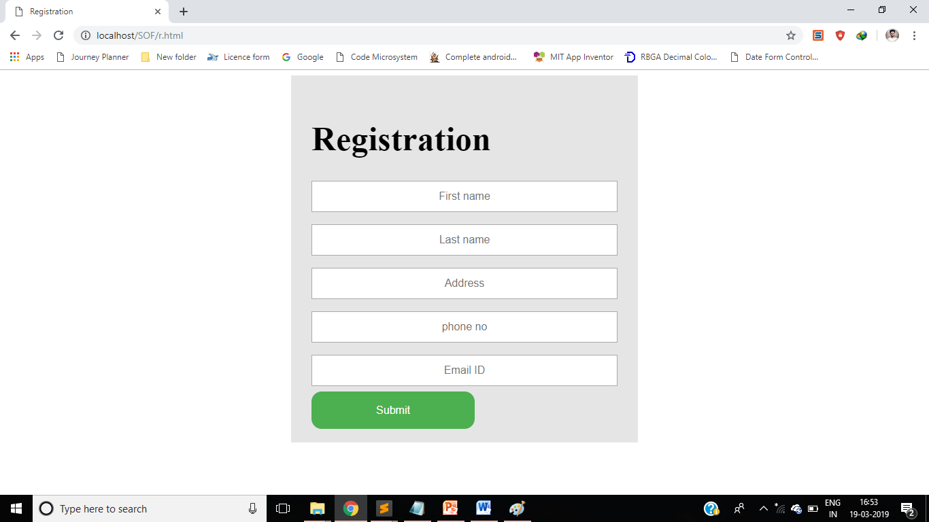

**Fig. 5.3**

**LOGIN FOR ADMIN:** The data registered by the users and the visitors will only be accessed by the admin. The admin will be provided will the unique username and password so that no one can get access to the confidential data of the system.

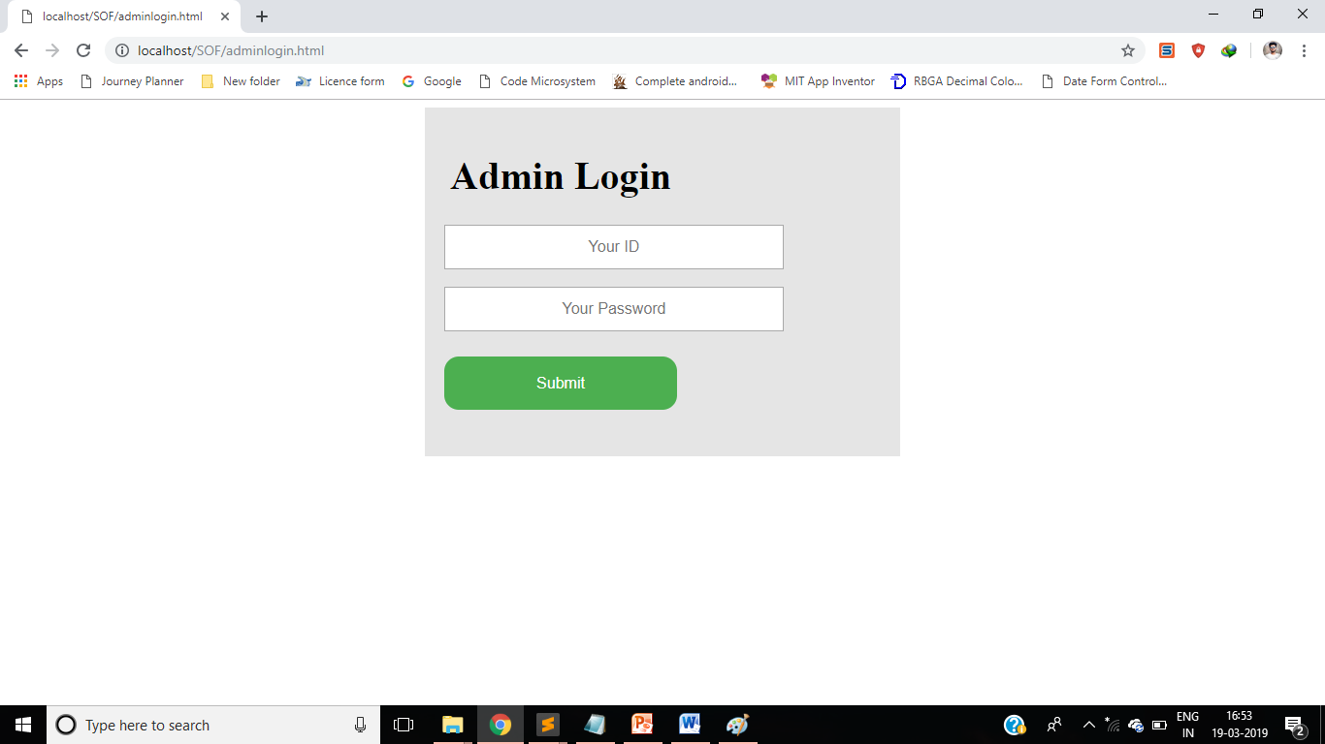

**Fig. 5.4**

**DATABASE:** It includes the data of the customers who registered into the system and the visitors who visited to the site.

**Fig. 5.5**

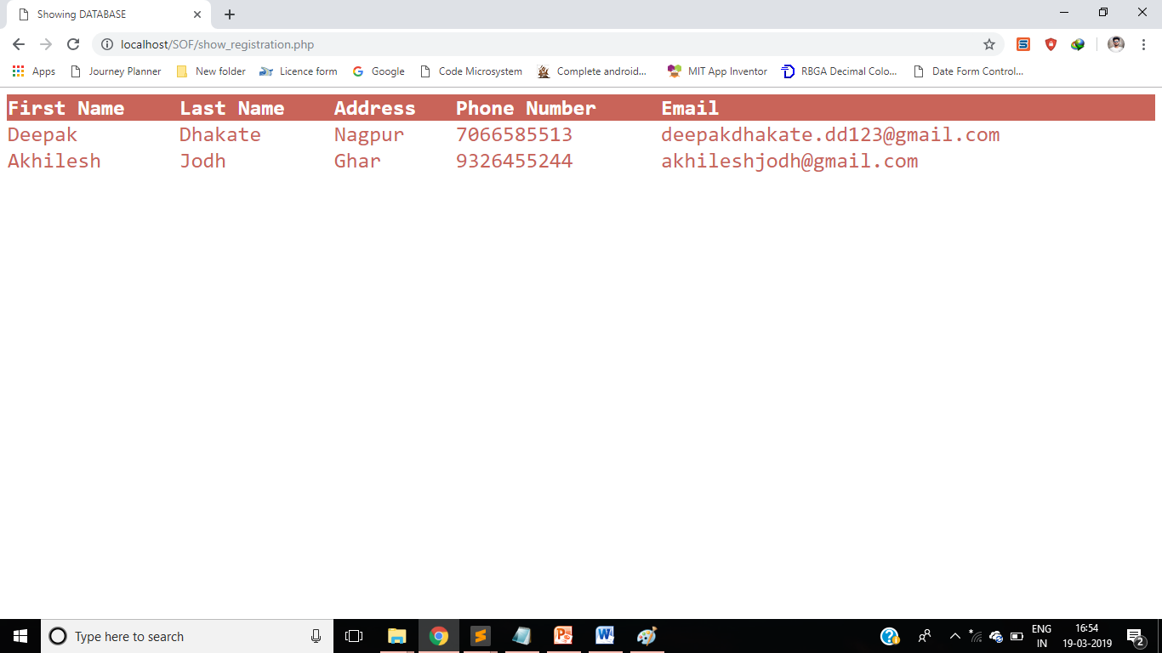

**SERVICES:** The different services provides by us includes Personal Training, Group, Group Fitness Classes, Yoga Classes, Strength Training, etc.

.

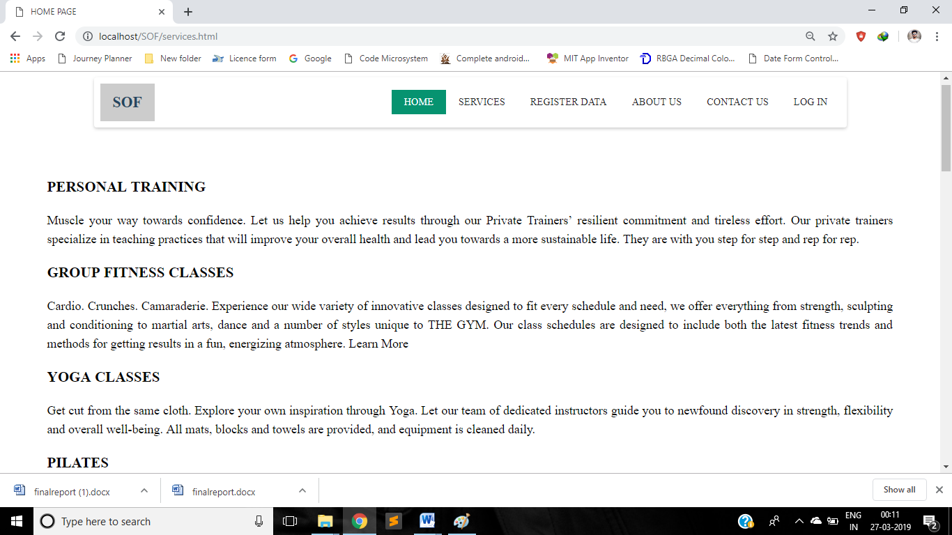

**Fig. 5.6**

**PROJECT TESTING**

The testing phase is an important part of software development. It is the process of finding errors and missing operations and also a complete verification to determine whether the objectives are met and the user requirements are satisfied.

Software testing is carried out in three steps:

     The first includes unit testing, where in each module is tested to provide its correctness, validity and also determine any missing operations and to verify whether the objectives have been met.

It included

* Testing of navigation bar finding whether it is working properly.
* Testing of Registration form regarding the linkage of it with the database.
* Checking whether the registered admin only has an access to the database where the personal information about the customer is saved.
* Storing the customer’s data securely.

       The second step includes Integration testing. It need not be the case, the software whose modules when run individually and showing perfect results, will also show perfect results when run as a whole.

It included

* As earlier, we have connected the login form to the database and also the registration form to the database.so, now we are connecting together different components such as Home page, Services, Register, Contact us, About us and login form.

       The final step involves validation and testing which determines which the software functions as the user expected. Here also some modifications were.

It includes

* Testing whether the system is reliable to the requirements of the customer and maintaining customer’s data securely.

**CONCLUSIONS AND FURTHER SUGGESTED WORK**

**7.1 CONCLUSION**

* The objective of the project was to build a program for maintaining the details of all the members. The security of the system is also one of the prime concerns.
* Goal achieved: The customer’s data is handled efficiently using this software.
* User friendliness: Admin can easily access the data by just the click of his fingers i.e. the data of any member can be accessed by him within the fractions of second.

**7.2 FURTHER SUGGESTED WORK**

The project has been developed in a very short period of time and all efforts have been taken so that this project is very efficient in its execution there still exists some scope of improvement in our project. The following lists some of the enhancement that can be added incorporate into the project. Application of the project can be done more attractively. Database management and all maintenance module can be updated which helps the administrator. More security measures can be taken. There are also few features which can be integrated with this system to make it more flexible.

**REFERENCES**

[1]. JECOBERTH WAIGAEMO KENDIGA 140.13.009 “Gym Management System of Taurama Fitness centre” in 2017 by Computer University Of Indonesia. Taurama Fitness centre is one of the few gym training centre in port Moresby, Papua New Guinea which was founded in 2009, by johnson Waldford

[2].Monir Ahmed ID: 2012-2-60-048 & Jannatun Nayeem ID: 2012-2-60-050 on Gym Management System.

**9.1 PROGRAM OUTCOMES (POs)**

* **PO1: Engineering Knowledge –**

Apply the knowledge of mathematics, science, engineering fundamentals and an engineering specialization to the solution of complex engineering problems.

* **PO2 : Problem Analysis –**

Take up responsibility in identify, formulate, review literature and analyze complex engineering problems related to CT and reaching substantiated conclusions using first principles of mathematics, natural sciences and engineering sciences.

* **PO4 : Conduct Investigations of Complex Problems –**

Use research based knowledge and research methods including design of experiments, analysis and interpretation of data, and synthesis of the information to investigate the complex problem and suggest probable solution.

* **PO5 : Modern Tool Usage –**

Create, select and apply appropriate techniques, resources and modern engineering and IT tools to computer technology related complex engineering activities with an understanding of the limitations.

* **PO9 : Individual and Teamwork –**

Execute the project development individually and also in a teamwork.

* **PO10 : Communication –**

Communicate effectively on complex engineering activities with the engineering community and with society at large such as able to comprehend and with write effective reports and design documentation, make effective presentations and give and receive clear instructions. Participate in academic activities such as group discussions, seminars, conferences and co-curricular and extra-curricular events.

* **PO11 : Project Management and Finance –**

Demonstrate knowledge and understanding of the engineering management principles and apply these to one’s own work, as a member and leader in a team, to manage projects in multi-disciplinary environments.

* **PO12 : Life-long Learning –**

Recognize the need for and have the preparation and ability to engage in independent and life-long learning the broadest context of technological change.

**9.2 PROGRAM SPECIFIC OUTCOMES (PSOs)**

* **PSO2** : Skills towards design of web based systems, mobile applications, big data, data analytics and data mining towards sustainable solutions.